**ENERGY EFFICIENT INDUSTRIAL FANS:**

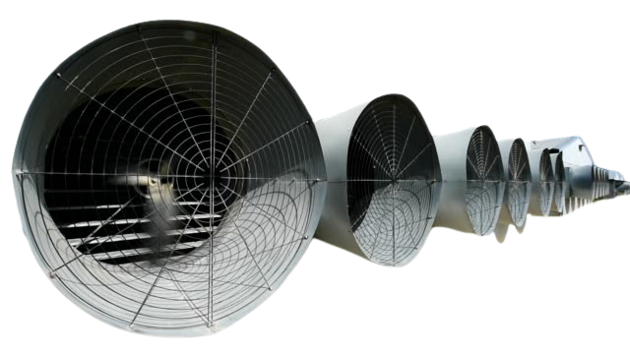

**Price: 17,500.00**

The Energy Efficient Industrial Fan is a high-performance ventilation solution, designed to provide powerful airflow while minimizing energy consumption. With its advanced motor technology and aerodynamic design, this fan delivers high-volume air movement while reducing energy costs. Its durable construction, adjustable speed settings, and eco-friendly design make it an ideal choice for environmentally conscious businesses and industries seeking to reduce their carbon footprint while maintaining a safe and comfortable working environment.

**Key features of energy efficient industrial fans include:**

* **Low Power Consumption**: Designed to use less electricity while maintaining high performance.
* **High Airflow Efficiency**: Moves large volumes of air with minimal energy use.
* **Variable Speed Controls**: Adjustable speeds for optimized energy usage based on needs.
* **Durable Construction**: Built to last with materials that withstand heavy-duty use.
* **Improved Motor Technology**: Uses advanced motors for better energy efficiency.
* **Eco-Friendly**: Reduces environmental impact by conserving energy.
* **Cost-Effective**: Lower operational costs due to reduced energy consumption.